
press release
MIR - MULTIMEDIA INTEGRATION EXPO, THE ONLY ITALIAN EVENT DEDICATED TO INNOVATION IN INTEGRATED SYSTEMS FOR PROFESSIONAL AUDIOVISUAL AND ENTERTAINMENT TECHNOLOGY RETURNS TO RIMINI FROM APRIL 12 TO 14, 2026
- Curated by Italian Exhibition Group at Rimini Expo Centre, the ninth edition showcases cutting-edge technologies and exclusive formats for the AV community.
- Confirmed for 2026: the exclusive formats Live You Play (with the Sound Power arena) and MIR Club, Europe’s only trade fair space dedicated to DJ and club culture.
- A unique experiential and educational platform, featuring live demos, immersive rooms, interactive stages, and vertical training paths for today’s professionals and tomorrow’s talent.

Rimini, 26 June 2025 – Following a highly successful 2025 edition, MIR – Multimedia Integration Expo returns from April 12 to 14 in 2026, to Rimini Expo Centre, curated by Italian Exhibition Group (IEG). The show continues to establish itself as the go-to Italian event for integrated technologies in audio, video, lighting, and control, with applications across corporate, education, museums, retail, broadcast, and live events.
In 2025, MIR saw a 30% increase in attendance compared to the previous year, featuring over 200 exhibiting brands, 15% of which were international. The foreign audience accounted for 19% of the total, with strong participation from Germany, the United Kingdom, China, and the Netherlands, confirming the event's international appeal.
MIR stands out with its unique hybrid and original trade fair format, blending exhibition spaces, hands-on experiences, and high-value professional content. Unlike traditional trade shows, MIR integrates exclusive formats designed to actively engage the entire AV and entertainment community.
As the professional audiovisual industry is increasingly embracing experiential technologies, isolated demos are no longer enough. What’s needed is an integrated approach—one that offers spaces to test, learn, exchange ideas, and do business. In this context, events like MIR provide a tangible platform for a new generation of professional gatherings, built around a specialized community and powered by immersive formats and targeted educational content aimed at driving industry transformation.
In Europe, the immersive entertainment industry—which includes virtual reality, multisensory environments, and integrated installations—generated over $25.7 billion in 2024, with projected growth of 27.5% CAGR through 2030 (source: Grand View Research, “Immersive Entertainment Europe 2024”). This strong upward trend highlights the increasing demand for engaging, technology-driven experiences, which are becoming central to industries such as education, retail, and entertainment.
At MIR 2026, two standout original formats are confirmed, both of which drew significant attention and participation from professionals and attendees in previous editions. This comes within a global sector valued at $325 billion in 2024, with a 6.1% year-on-year growth, driven by live events, education, and corporate installations (source: AVIXA – Industry Outlook Trends Analysis 2024).
- Live You Play returns with its proven immersive format, allowing visitors to test audio, video, and lighting systems in real performance conditions. Also confirmed is the Sound Power outdoor arena, introduced in 2025, which offers sound engineers, technicians, and service providers the opportunity to compare top-tier professional audio systems in realistic operational settings.
- MIR Club, now in its third edition, remains Europe’s only exhibition space dedicated to DJ and club culture. Developed in partnership with DJ Mag Italia, it combines the largest national showcase of DJ consoles and technologies with training programmes, networking opportunities, and meetings with artists, record labels, producers, and key figures in the music industry—creating a space where ideas, skills, and new projects converge.
Looking ahead, MIR 2026 will further strengthen its experiential format, featuring live demos, interactive stages, immersive rooms, and vertical pathways tailored to evolving markets. This evolution is made possible through strategic collaboration with industry associations, leading tech brands, and education partners, ensuring a dynamic and high-level environment where knowledge becomes opportunity—for business, relationships, and professional growth.
With its innovative, immersive, and community-driven approach, MIR redefines the trade show experience. It serves as a platform where technological innovation meets professional development, fostering meaningful connections among industry stakeholders. An event designed not only for today’s professionals, but also for the next generation set to shape the future of the AV and entertainment sectors.
ABOUT MIR 2026
Date: 12-14 Aprile 2026; event type: international show; organiser: Italian Exhibition Group S.p.A.; frequency: annual; edition: 9th; open to: general public and industry professionals; info: www.mirtechexpo.com

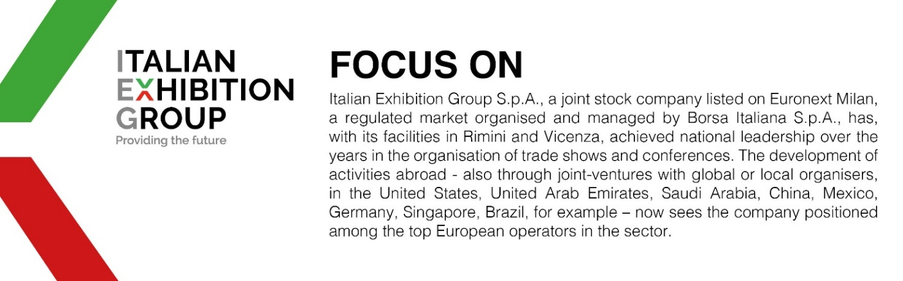

PRESS CONTACT ITALIAN EXHIBITION GROUP
head of corporate communication & media relation: Elisabetta Vitali
press office manager: Marco Forcellini, Pier Francesco Bellini | press office coordinator: Luca Paganin | international press office coordinator: Silvia Giorgi | press office specialist: Mirko Malgieri; Nicoletta Evangelisti, media@iegexpo.it

This press release contains forecast elements and estimates that reflect the management’s current opinions (“forward-looking statements”), particularly regarding future management performance, realization of investments, cash flow trends and the evolution of the financial structure. For their very nature, forward-looking statements have a component of risk and uncertainty, as they depend on the occurrence of future events. The effective results may differ (even significantly) from those announced, due to numerous factors, including, only by way of example: food service market and tourist flow trends in Italy, gold and jewellery market trends, green economy market trends; the evolution of raw material prices; general macroeconomic conditions; geopolitical factors and evolutions in the legislative framework. Moreover, the information contained in this release does not claim to be complete, and has not been verified by independent third parties. Forecasts, estimates and objectives contained herein are based on the information available to the Company as at the date of this release.

