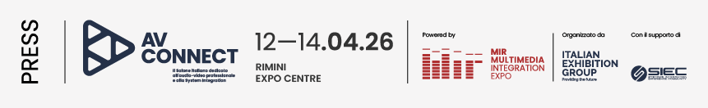
press release no. 2

MIR 2026 PRESENTS AV CONNECT, THE NEW PROFESSIONAL AUDIO VIDEO AND SYSTEM INTEGRATION FORMAT

- The new edition of IEG’s event on technologies for the performing arts and live entertainment will feature a new area for AV professionals
- An area entirely centred on System Integration, operational and interoperable solutions
- From 12th to 14th April 2026, in Hall A1 at Rimini Expo Centre

Rimini, 12-14 April 2026 – AV Connect, the new trade show project entirely dedicated to professional audio-visual technology and System Integration, will be making its debut at MIR 2026 – Multimedia Integration Expo, scheduled to take place from 12th to 14th April 2026 at Rimini Expo Centre. An ecosystem designed to offer the Italian AV community a practical and specialised hub centred on real-life applications.
Conceived as an exclusive area within MIR, the project aims at system integrators, installers, designers, ICT managers, facility managers and decision-makers who are looking for practical, testable and immediately implementable solutions. Created in collaboration with SIEC – Systems Integration Experience Community and the sector’s leading brands, AV Connect will provide a comprehensive overview of integrated solutions for audio, video and control, with a focus on interoperability, standards and professional best practice. Not just an exhibition, but a platform where technology, expertise and business come together.

TECHNOLOGY TO TEST, REAL-WORLD MARKETS, PROFESSIONAL COMMUNITY
What sets this project apart is its experiential approach; indeed, technologies are not merely outlined, but put into practice. Operational audio-visual systems, immersive environments and integrated solutions will enable visitors to grasp the real-life impact of technological decisions, going beyond technical specifications and theoretical explanations. In this specific area, visitors will be able to see operational systems in action, consult with qualified integrators and designers, evaluate concrete application scenarios and explore the developments that are redefining the AV sector. A unique environment where applications for the corporate, retail, education, museum and other sectors merge, demonstrating how professional AV can respond to diverse but always practical needs. Networking and community will also be at the heart of the event with the involvement of decision-makers at all levels of the industry: from technical discussions to building lasting professional relationships. The initiative will therefore act as a hub for connection and growth for the entire sector.

TOWARDS THE FUTURE OF PROFESSIONAL AUDIO-VIDEO
AV Connect will explore the sector’s present and future through the key themes that are driving its evolution, from advanced System Integration to AV-over-IP standards and collaborative solutions for hybrid and connected workplaces. The common theme will be integration with a growing focus on sustainability, scalability and efficiency.
AV CONNECT IS PART OF MIR
MIR offers a consolidated trade show ecosystem, recognised and attended by a highly qualified professional community. The project, hosted in Hall A1, extends the scope of the event with a specialised focus on professional audio-visual and System Integration, thereby strengthening the event’s international standing.

ABOUT MIR 2026
Dates: 12/14 April 2026; event: international trade show; organisation: Italian Exhibition Group S.p.A.; frequency: annual; edition: 9th; entry: public and trade; info: www.mirtechexpo.com

PRESS CONTACT ITALIAN EXHIBITION GROUP
head of corporate communication & media relation: Elisabetta Vitali
press office manager: Marco Forcellini, Pier Francesco Bellini | press office coordinator: Luca Paganin | press office specialist: Mirko Malgieri; Nicoletta Evangelisti | press office assistant: Julia Andreatta media@iegexpo.it

MEDIA AGENCY MIR
Naper Multimedia| Zoe Perna | T. +39 02 97699600 | zoe.perna@napermultimedia.it | staff@napermultimedia.it

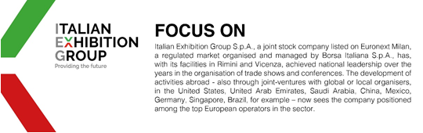

This press release contains forecast elements and estimates that reflect the management´s current opinions (´forward-looking statements´), particularly regarding future management performance, realization of investments, cash flow trends and the evolution of the financial structure. For their very nature, forward-looking statements have a component of risk and uncertainty, as they depend on the occurrence of future events. The effective results may differ (even significantly) from those announced, due to numerous factors, including, only by way of example: food service market and tourist flow trends in Italy, gold and jewellery market trends, green economy market trends; the evolution of raw material prices; general macroeconomic conditions; geopolitical factors and evolutions in the legislative framework. Moreover, the information contained in this release, does not claim to be complete, and has not been verified by independent third parties. Forecasts, estimates and objectives contained herein are based on the information available to the Company as at the date of this release.

