

press release no. 4

IEG: MIR 2026 IGNITES THE DEBATE ON MAN AND CREATIVE MACHINE
IN THE ARTS AND ENTERTAINMENT

- The IEG event, at Rimini Expo Centre from 12–14 April, will host the conference entitled “Human After All?”, a reflection on the future of creativity in the age of artificial intelligence
- Technological innovation and human talent will take centre stage at Italy’s leading event for entertainment and creative industry technologies
- MIRIllumino will make its debut: the anonymous technical challenge that puts lighting technologies to the test, regardless of brand

Rimini, 12-14 April 2026 – In a historic moment when artificial intelligence is radically redefining creative, production and distribution processes, MIR – Multimedia Integration Expo 2026 has decided to question one of the most pressing issues of our time: the role of man in the face of increasingly creative machines. Organised by IEG – Italian Exhibition Group and scheduled to take place from 12th to 14th April 2026 at Rimini Expo Centre, Italy’s leading event on technologies for the entertainment and creative industries will include a structured reflection on the relationship between technological innovation and artistic talent, placing the conference entitled “Human After All? Man and machine at the heart of the future of contemporary creativity” at the centre of the three-day event.

HUMAN AFTER ALL? CREATIVITY IN THE AGE OF ARTIFICIAL INTELLIGENCE
Nowadays, machines no longer merely assist humans; they learn, compose, generate images, write texts and create music. In an age where innovation is increasingly measured in terms of data and algorithms, MIR 2026 will put the focus back on people, highlighting how the real difference lies not only in the ability to produce content, but in the uniquely human capacity to interpret, evoke emotion and give meaning to technology. The “Human After All?” event, scheduled for Monday 13th April at 12 noon during the IEG Show, originates precisely from this tension, and, while not meant as a confrontation between man and machine, will offer a reflection on the new forms of co-creation that are redefining contemporary creativity. The conference will be a key event in this rapidly evolving landscape for those working in the performing arts, the audiovisual sector, live entertainment and immersive environments, who interact on a daily basis with tools based on AI, automation and intelligent systems. Given that understanding this change is no longer an option but a professional and cultural responsibility, the event offers a vision of the future of creativity in the modern era by posing a question that is bound to lead the debate in the coming years.

MIRILLUMINO: WHEN THE PRODUCTS SPEAK FOR THEMSELVES
Alongside its theoretical and visionary elements, MIR 2026 will also present MIRIllumino, a unique and unprecedented immersive format, scheduled for Monday and Tuesday in Hall A6. As part of LD@Work, organised by lighting designers Giovanni Pinna and Marco Zucchinali, this area, entirely dedicated to lighting technology and innovation, will involve a highly qualified audience of technical lighting designers, lighting system programmers, set designers, technicians and creatives, invited to express a satisfaction rating based purely on visual experience. The heart of the event will be an authentic shoot-out between products completely “stripped” of their brand, name and model. The lights, concealed and physically unrecognisable, will be assessed solely on their performance in terms of light quality, colour rendering, power, precision and spatial behaviour. In this context, it will be the light and not the brand that speaks. The next day, discussion will shift from the visual to the analytical with a Round Table session between various lighting designers with the aim of exploring, through direct dialogue, the technical and creative criteria that lead to choosing one product over another. The technical challenge thus becomes a topic of discussion. What the audience saw and assessed will be re-examined, interpreted and discussed by the experts, transforming the experience into shared content.

ABOUT MIR 2026
Dates: 12/14 April 2026; event: international trade show; organisation: Italian Exhibition Group S.p.A.; frequency: annual; edition: 9th; entry: public and trade; info: www.mirtechexpo.com

PRESS CONTACT ITALIAN EXHIBITION GROUP
head of corporate communication & media relation: Elisabetta Vitali
press office manager: Marco Forcellini, Pier Francesco Bellini | press office coordinator: Luca Paganin | press office specialist: Mirko Malgieri; Nicoletta Evangelisti | press office assistant: Julia Andreatta media@iegexpo.it
MEDIA AGENCY MIR
Naper Multimedia| Zoe Perna | T. +39 02 97699600 | zoe.perna@napermultimedia.it | staff@napermultimedia.it

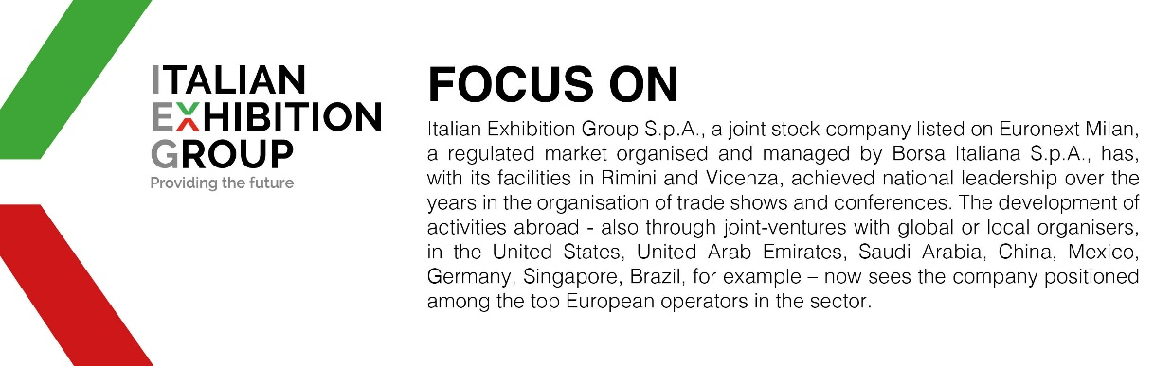

This press release contains forecast elements and estimates that reflect the management´s current opinions (´forward-looking statements´), particularly regarding future management performance, realization of investments, cash flow trends and the evolution of the financial structure. For their very nature, forward-looking statements have a component of risk and uncertainty, as they depend on the occurrence of future events. The effective results may differ (even significantly) from those announced, due to numerous factors, including, only by way of example: food service market and tourist flow trends in Italy, gold and jewellery market trends, green economy market trends; the evolution of raw material prices; general macroeconomic conditions; geopolitical factors and evolutions in the legislative framework. Moreover, the information contained in this release, does not claim to be complete, and has not been verified by independent third parties. Forecasts, estimates and objectives contained herein are based on the information available to the Company as at the date of this release.

