
press release no. 6

THE ENTERTAINMENT MARKET IN ITALY:
CONSOLIDATED RECOVERY AND NEW CONSUMPTION MODELS

A 4-million-euro industry: Italian entertainment is growing amid live experiences, new generations and technological innovation

Rimini, 12-14 April 2026 – The Italian live entertainment industry, whose flagship event is MIR – Multimedia Integration Expo, organised by IEG – Italian Exhibition Group, is consolidating its economic and social importance. In general, the entire cultural sector has reached a historic milestone with an estimated total turnover of around €4 billion and monthly per capita cultural spending at €94 this year compared to €90 in 2024, marking a recovery driven by the younger generations and consumption models increasingly focused on physical experiences and technological innovation.

DANCE HALLS AND NIGHTCLUBS: A TURNOVER OF MORE THAN €2 BILLION
The Italian dance hall and nightclub sector, which comprises some 2,500 active businesses across the country, is still a significant economic asset with a total turnover in excess of €2 billion. Of this figure, €500 million come from direct revenue, whilst a further €1.5 billion is generated by related industries, supporting a workforce of around 50,000 employees. With over 34 million patrons a year, the sector responds to a constant social demand: 88.7% of Italians say they go out at least once a week for leisure, and of these, almost 39% choose dancing with one in three Italians regularly going to nightclubs. At the ninth edition of MIR, it is clear that the future of the sector lies in a hybridisation. Indeed, the most popular choice of location is a combination between traditional clubbing and other types of venue such as live music bars and beach clubs, outlining new business models able to integrate technological innovation, musical offerings and new forms of hospitality.
SILB-FIPE / Confcommercio data on summer 2025

CONSUMER TRENDS AND PARTICIPATION: THE VALUE OF THE LIVE EXPERIENCE
Italian habits paint a cultural picture in which, alongside watching television programmes and films at home, which accounts for 93% of the population, listening to music, whether live or at home, is enjoyed by 83% of those interviewed. The figures relating to social activities are particularly significant: 42% of Italians attend outdoor shows and 39% go to concerts. Cinema accounts for 48%. To be more precise, the entertainment sector confirmed an extremely positive growth trend over the past year with the cinema reporting a particularly noteworthy performance with a total 31 million admissions in the first six months of 2025, an increase of 11%, and box office takings of €228.4 million. Positive results were also seen in the concerts segment, which, with 7.3 million attendees and growth of 1.6%, generated revenues of €256.5 million, as well as in the theatre sector, which recorded an increase of 3.9% with 15.4 million attendees and total box office takings of €325 million.

TOWARDS SUMMER 2026: THE 2025 NUMBERS
In the summer of 2025, the Italian nightlife sector recorded an estimated turnover growth of between 3 and 4% compared with the previous year, confirming the nightclub sector as one of the driving forces behind Italian tourism and culture. This positive trend is particularly pronounced in southern Italy and the islands, driven by tourism and the quality of the offering. In 2024, the sector had already generated nearly €500 million in revenue with over 34 million visitors and more than 200,000 events. The survey also highlighted the central role of the summer season with around 40% of total spending concentrated between June and August, and the importance of investing in venue safety, inclusivity and quality of experience.

(Sources: SIAE – Confcommercio Business and Culture Observatory - SILB)

ABOUT MIR 2026
Dates: 12/14 April 2026; event: international trade show; organisation: Italian Exhibition Group S.p.A.; frequency: annual; edition: 9th; entry: public and trade; info: www.mirtechexpo.com

PRESS CONTACT ITALIAN EXHIBITION GROUP
head of corporate communication & media relation: Elisabetta Vitali
press office manager: Marco Forcellini, Pier Francesco Bellini | press office coordinator: Luca Paganin | press office specialist: Mirko Malgieri; Nicoletta Evangelisti | press office assistant: Julia Andreatta media@iegexpo.it
MEDIA AGENCY MIR
Naper Multimedia| Zoe Perna | T. +39 02 97699600 | zoe.perna@napermultimedia.it | staff@napermultimedia.it

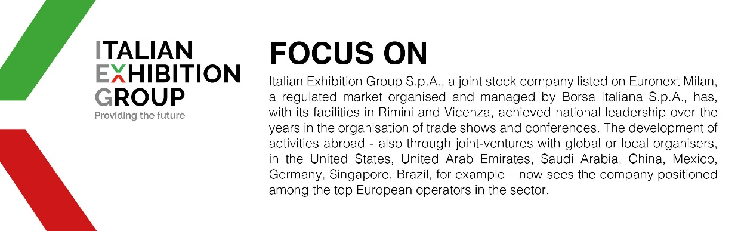

This press release contains forecast elements and estimates that reflect the management´s current opinions (´forward-looking statements´), particularly regarding future management performance, realization of investments, cash flow trends and the evolution of the financial structure. For their very nature, forward-looking statements have a component of risk and uncertainty, as they depend on the occurrence of future events. The effective results may differ (even significantly) from those announced, due to numerous factors, including, only by way of example: food service market and tourist flow trends in Italy, gold and jewellery market trends, green economy market trends; the evolution of raw material prices; general macroeconomic conditions; geopolitical factors and evolutions in the legislative framework. Moreover, the information contained in this release, does not claim to be complete, and has not been verified by independent third parties. Forecasts, estimates and objectives contained herein are based on the information available to the Company as at the date of this release.

