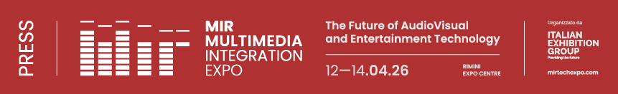

press release no. 7

THE MIR 2026 LAYOUT

Rimini, 12-14 April 2026 – The ninth edition of MIR – Multimedia Integration Expo will occupy 10 halls at Rimini Expo Centre which can be accessed from the South Hall (South Entrance, via Emilia, 155 – Rimini).

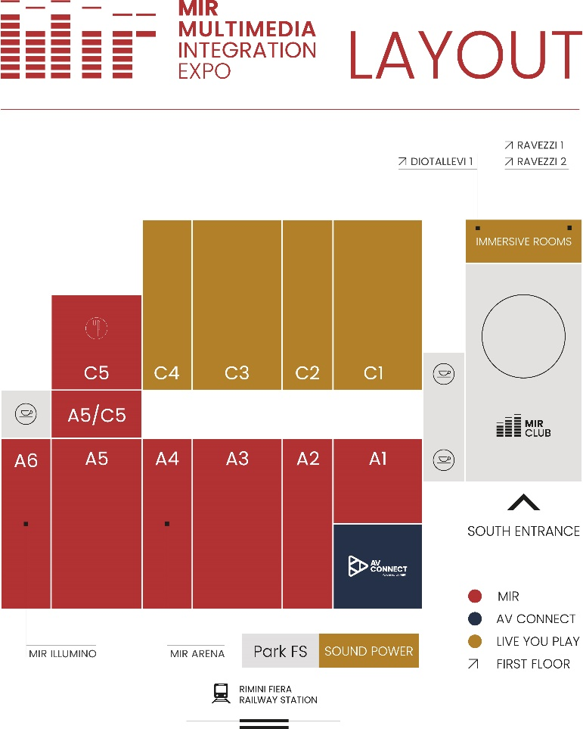

MIR CLUB, the format specifically for makers and enthusiasts in the field of DJing and Music Entertainment, will be located in the South Hall, while the Immersive Sound Rooms will be set up for demos on the first floor. Halls A1, A2, A3, A4, A5 (C5) and A6 will host MIR, the exhibition area where solutions designed by leading companies in the fields of audio, video, lighting, education, retail, museums, hospitality, live events and System Integration will be on display. Hall A1 will be hosting the debut of AV CONNECT , MIR’s new professional audio-video and system integration area. The LIVE YOU PLAY format will be set up in Halls C4, C3, C2 and C1, featuring the famous stages where all the audio, video and lighting technologies will be on display, switched on and fully operative ready for testing.
Lastly, Sound Power, an outdoor area with high sound pressure levels where visitors will be able to test the performance of some of the world’s most advanced audio systems under real-life conditions, will be located in the FS Station Car Park.

ABOUT MIR 2026
Dates: 12/14 April 2026; event: international trade show; organisation: Italian Exhibition Group S.p.A.; frequency: annual; edition: 9th; entry: public and trade; info: www.mirtechexpo.com

PRESS CONTACT ITALIAN EXHIBITION GROUP
head of corporate communication & media relation: Elisabetta Vitali
press office manager: Marco Forcellini, Pier Francesco Bellini | press office coordinator: Luca Paganin | press office specialist: Mirko Malgieri; Nicoletta Evangelisti | press office assistant: Julia Andreatta media@iegexpo.it
MEDIA AGENCY MIR
Naper Multimedia| Zoe Perna | T. +39 02 97699600 | zoe.perna@napermultimedia.it | staff@napermultimedia.it

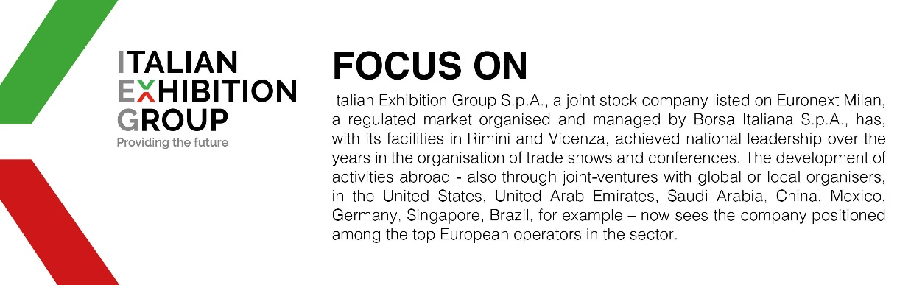

This press release contains forecast elements and estimates that reflect the management´s current opinions (´forward-looking statements´), particularly regarding future management performance, realization of investments, cash flow trends and the evolution of the financial structure. For their very nature, forward-looking statements have a component of risk and uncertainty, as they depend on the occurrence of future events. The effective results may differ (even significantly) from those announced, due to numerous factors, including, only by way of example: food service market and tourist flow trends in Italy, gold and jewellery market trends, green economy market trends; the evolution of raw material prices; general macroeconomic conditions; geopolitical factors and evolutions in the legislative framework. Moreover, the information contained in this release, does not claim to be complete, and has not been verified by independent third parties. Forecasts, estimates and objectives contained herein are based on the information available to the Company as at the date of this release.

