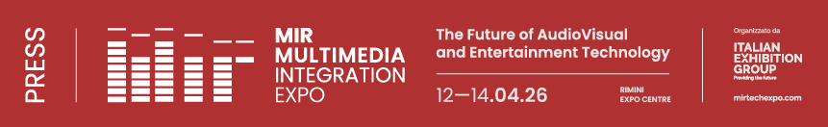

press release no. 8

GETTING TO MIR IS EASY, FAST AND WITHIN EVERYONE’S REACH

Service guide for Multimedia Integration Expo scheduled to take place from 12th to 14th April at Rimini Expo Centre
Rimini, 12-14 April 2026 – How do you get to MIR – Multimedia Integration Expo 2026? With a range of transport services that Italian Exhibition Group has organised to enable visitors and trade professionals to arrive at the Expo Centre easily in order to attend the event.
Entry into the Expo Centre: from the South Hall (via Emilia, 155).
Opening times: Sunday 12th and Monday 13th April, from 10 am to 6.30 pm. Tuesday 14th April, from 10 am to 5 pm.
Ticket Office: entry subject to prior registration. €20 (1 day) or €15 (1 day, available for purchase online up until 11/04 at 11:59 pm)
Visitor Helpdesk: for assistance, call +39 0541 744555 from Monday to Friday, from 9 am to 1 pm, or send an email to: helpdesk.rn@iegexpo.it. Otherwise, fill in the online form at the following link.
It is advisable to pre-register at this link, print out the ticket and go directly to the turnstiles.

HOW TO GET TO THE EXPO CENTRE
Trains: Rimini Expo Centre is the only one of its kind in Italy to have its own internal railway station on the Milan–Bari line. Regional train timetables are available at this address. Since these times may change, we recommend also checking the Trenitalia website, entering “Rimini Fiera” as the departure or destination and the exact date. RFI provides an assistance service for passengers with disabilities or reduced mobility, which must be booked at least 12 hours in advance. The service provided is exclusively to assist with boarding and alighting from the train and does not include accompaniment inside the Expo Centre. The meeting point is at the railway station ticket office. Further information is available on the RFI website under the “Station Accessibility” section.
Public transport: Bus route no. 9 runs from Rimini Central railway station, connecting with the Metromare services during peak times. Alternatively, route no. 10 runs from Rimini South (Miramare) and route no. 5 from Rimini North (Torre Pedrera). Further information is available on this link. Passenger travelling on public transport services must have a valid ticket. Various types of multi-day passes are available. Further information here.
E-mobility: bicycles, e-bikes and electric scooters managed by Lime and BIT MOBILITY sharing companies are available for use inside the Expo Centre grounds through apps that can be downloaded from Google Play Store or App Store. Further information regarding discounts and promotions can be found on this link under “Electric micro-mobility”.
Info about cars, parking, care hire with and without driver, and taxis: : Rimini Expo Centre (Via Emilia 155) is connected to the A14 motorway (Bologna–Bari–Taranto), which in turn links up with the main European motorways. It is 6 km from the Rimini North motorway exit. Six electric vehicle charging points are available for exhibitor and visitor use in the car parks, providing a total of 12 sockets (Type 2, with user’s own cable). For those travelling to the Expo Centre by car hire, discounted rates are available with AVIS Car Hire to and from Rimini expo Centre. For further information: (+39) 0541/51256 - 199 100 133 - www.avisautonoleggio.it.
A taxi service is available by calling (+39) 0541 50020 - www.radiotaxirimini.it, as well as a car hire with driver service from Shuttle Italy Airport at the following number: (+39) 0541/600100

To find out about all the services for getting to MIR, please go to the following website: https://www.mirtechexpo.com/it/organizza-soggiorno/come-arrivare

ABOUT MIR 2026
Dates: 12/14 April 2026; event: international trade show; organisation: Italian Exhibition Group S.p.A.; frequency: annual; edition: 9th; entry: public and trade; info: www.mirtechexpo.com

PRESS CONTACT ITALIAN EXHIBITION GROUP
head of corporate communication & media relation: Elisabetta Vitali
press office manager: Marco Forcellini, Pier Francesco Bellini | press office coordinator: Luca Paganin | press office specialist: Mirko Malgieri; Nicoletta Evangelisti | press office assistant: Julia Andreatta media@iegexpo.it
MEDIA AGENCY MIR
Naper Multimedia| Zoe Perna | T. +39 02 97699600 | zoe.perna@napermultimedia.it | staff@napermultimedia.it

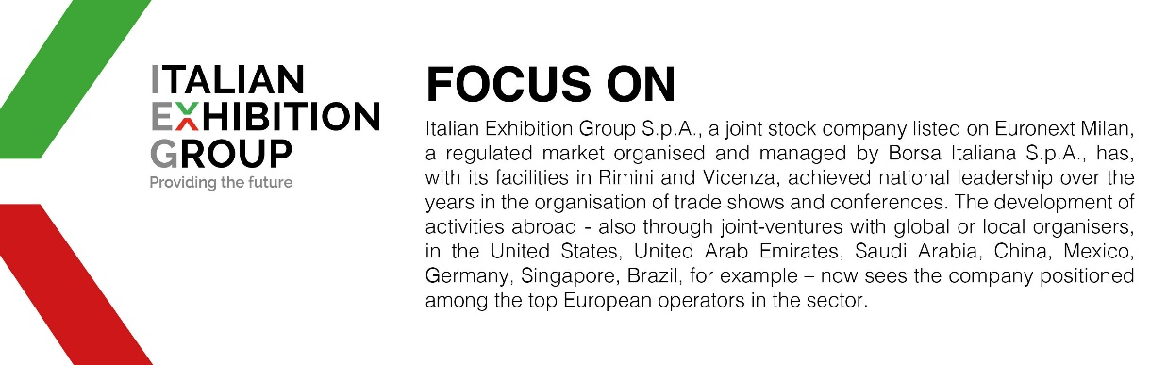

This press release contains forecast elements and estimates that reflect the management´s current opinions (´forward-looking statements´), particularly regarding future management performance, realization of investments, cash flow trends and the evolution of the financial structure. For their very nature, forward-looking statements have a component of risk and uncertainty, as they depend on the occurrence of future events. The effective results may differ (even significantly) from those announced, due to numerous factors, including, only by way of example: food service market and tourist flow trends in Italy, gold and jewellery market trends, green economy market trends; the evolution of raw material prices; general macroeconomic conditions; geopolitical factors and evolutions in the legislative framework. Moreover, the information contained in this release, does not claim to be complete, and has not been verified by independent third parties. Forecasts, estimates and objectives contained herein are based on the information available to the Company as at the date of this release.

