
press release no. 9

IEG: AT MIR 2026, THE TRADE SHOW SECTOR ADDRESSES SKILLS AND INCLUSION
- Prostand promotes specialised training as a strategic lever for development and inclusion across the entire sector
- The "Backstage on Stage" round table will see institutions and industry leaders discuss skill certification and employee well-being with opening remarks by Rimini Mayor Jamil Sadegholvaad
- The debate will explore the value of personal training, promoting equity and equal opportunities

Rimini, 12-14 April 2026 – In an industry that demands speed, projectuality and constant updating, training is a strategic tool for building solid, recognised skills. This is the central theme of “Backstage on Stage”, the round-table discussion organised by Prostand Corporate Academy and ObService – an organisation accredited by the Emilia-Romagna Region – scheduled for 14th April at 2.30 pm as part of MIR – Multimedia Integration Expo, Italian Exhibition Group’s (IEG) trade show for audio, video and lighting technologies for events, that will be taking place at Rimini Expo Centre from 12th to 14th April 2026.
The meeting will see institutions, companies and the education sector come together to explore the role of training in the trade show and events industry, a constantly evolving ecosystem that thrives on qualified professionalism and the ability to innovate.
Key speakers at the event will include Vincenzo Colla, Vice-President of the Emilia-Romagna Region, who will talk about the link between public policy, economic development and promoting skills. Joining him will be Corrado Peraboni, CEO of IEG, and Roberto Bondioli, CEO of Prostand, for an industrial and operational perspective that has matured within the trade show sector, with a particular focus on the role of continuous training, skill certification processes and integrating D&I principles into corporate strategies. The debate will open with an official welcome address from Rimini Mayor, Jamil Sadegholvaad.
Carmelina Fierro, an occupational psychologist and expert in equal opportunities, will further enrich the debate with a perspective centred on the human dimension of training, while Oriana Ciarrocchi, president of the ItalShow Scientific Committee, will explore the topics of technical skills, safety and the evolution of professional roles. The last panel member will be Chiara Mussoni, director of ObService – Città dei Maestri, who will explain the role of accredited bodies in designing training programmes that are consistent with corporate needs and geared towards inclusion. The discussion will be moderated by Carolina Marinelli, who will guide the dialogue between the various players involved whilst keeping the focus on the practical value of skills.
During the event, diplomas will be awarded to Sound Engineers (2025) and certificates to Wood Technologists (2026), underscoring the direct link between qualified training and job opportunities.
With this first-class event, Prostand Exhibition will strengthen its ties with the trade show, not only as a leading provider of temporary architecture, but also as a driver of growth for the entire sector through the Prostand Corporate Academy. Indeed, the Academy’s mission is to foster personal development through specialised training that nurtures individual talent, promotes inclusion and ensures the well-being of employees, thereby enhancing their perception of the value of their work.

ABOUT MIR 2026
Dates: 12/14 April 2026; event: international trade show; organisation: Italian Exhibition Group S.p.A.; frequency: annual; edition: 9th; entry: public and trade; info: www.mirtechexpo.com

PRESS CONTACT ITALIAN EXHIBITION GROUP
head of corporate communication & media relation: Elisabetta Vitali
press office manager: Marco Forcellini, Pier Francesco Bellini | press office coordinator: Luca Paganin | press office specialist: Mirko Malgieri; Nicoletta Evangelisti | press office assistant: Julia Andreatta media@iegexpo.it
MEDIA AGENCY MIR
Naper Multimedia| Zoe Perna | T. +39 02 97699600 | zoe.perna@napermultimedia.it | staff@napermultimedia.it

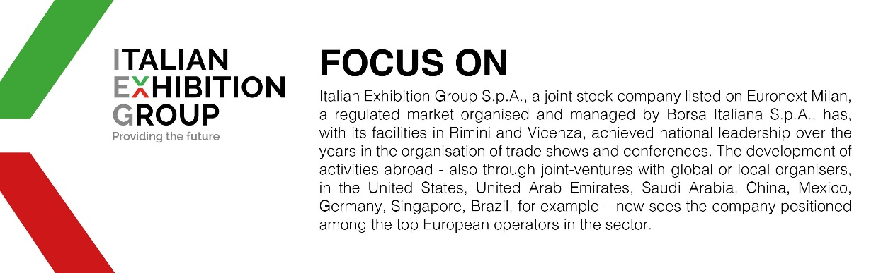

This press release contains forecast elements and estimates that reflect the management´s current opinions (´forward-looking statements´), particularly regarding future management performance, realization of investments, cash flow trends and the evolution of the financial structure. For their very nature, forward-looking statements have a component of risk and uncertainty, as they depend on the occurrence of future events. The effective results may differ (even significantly) from those announced, due to numerous factors, including, only by way of example: food service market and tourist flow trends in Italy, gold and jewellery market trends, green economy market trends; the evolution of raw material prices; general macroeconomic conditions; geopolitical factors and evolutions in the legislative framework. Moreover, the information contained in this release, does not claim to be complete, and has not been verified by independent third parties. Forecasts, estimates and objectives contained herein are based on the information available to the Company as at the date of this release.

