

MIR 2026: MIR CLUB IS BACK IN RIMINI AS THE DJ CULTURE HUB HOSTING BIG NAMES IN MUSIC AND THE TECH INDUSTRY

- At Rimini Expo Centre from 12th to 14th April, the fourth edition of MIR CLUB, a consolidated hub for new live experiences, networking and training for DJs, producers and professionals
- Innovative formats such as the Vinyl Lounge, Demolition Panel, Cutting Club and Masterclab combine culture, technology and talent scouting
- Key features will include leading figures in Italian music such as Saturnino, Boosta and Andro, alongside Luca Agnelli’s console workflows and the Italian premiere of the Meet the Industry event
Rimini, 12-14 April 2026 – In a context of constant change in audiovisual and entertainment technologies, MIR – Multimedia Integration Expo, the IEG – Italian Exhibition Group event scheduled to take place from 12th to 14th April 2026, will be back at Rimini Expo Centre. A key event for professionals, companies and creatives that work with technology, MIR 2026 confirms its status as a premier platform for exploring the most advanced solutions for multimedia content production, management and usage. MIR Club, now at its fourth edition and staged in the South Hall, will be back to host music makers and enthusiasts of DJing and club culture. The aim is to create a structured hub for discussion, participation and networking, where the talent of performers can meet industry leaders’ pioneering initiatives.
DJ CULTURE MAGIC IN AN IMMERSIVE EXPERIENTIAL AREA
Part of the trade show, MIR Club is one of the most engaging and recognisable areas, offering a tangible and accessible experience in DJ culture and electronic music, thanks to the invaluable contribution of DJ Mag Italia, the sector’s most prestigious Italian publication. The event, free of charge and open to all, will feature an immersive setting that will take visitors on a journey to explore the languages, techniques and values of contemporary DJing. What makes this event unique is Italy’s largest open-access console exhibition, which will once again be hosting the Experience Arena where visitors will be able to test all the latest innovations in digital and analogue mixing. Educational and interactive activities will therefore provide an inclusive experience that goes beyond a mere technological demonstration and restores electronic music to its role as a shared cultural language.

LECTURES WITH GREAT MASTERS AND THE BEAT OF PERFORMANCE
With its now well-established format, this year MIR Club will further enhance its offer by combining top-quality training sessions with pure entertainment. The event’s live focus will kick off on Sunday 12th April led by DJ KOWU’s exploration into the art of the mashup and DJ Aladyn’s electrifying Selectavision show, featuring live basslines performed by Saturnino. Monday 13th April will see the debut of Masterclab, an educational programme on integration between live and studio-produced electronic music. Taking to the stage will be exceptional artists such as Saturnino, joined by Fresco, Boosta from Subsonica, ready to explore the world of hardware synths and DAWs, and Mark The Hammer, the hugely popular YouTuber, with his secrets for the ideal setup. Monday’s line-up will be rounded off with the exclusive Inside the Booth session with Luca Agnelli, who will be ready to reveal his creative approach, supported by the latest AlphaTheta technology, alongside exciting challenges such as the Open Format DJ Battle and the new Cutting Club format, a vibrant knockout scratch competition.

TALENT SCOUTING, ARTIFICIAL INTELLIGENCE AND TECH INNOVATION
MIR Club will also confirm its role as a key hub for professional development and critical debate. Sunday 12th April will once again feature the Demolition Panel, Italy’s most famous musical speed-date event, where young producers will be able to play their unreleased tracks to a panel of top-class judges, including the likes of Andro from Negramaro, Alex Gaudino, Albert Marzinotto and record executive Max Moroldo. On the same day, technological innovation will take centre stage at the “Suno o Suono?” panel, a much-needed discussion on the opportunities and challenges of Artificial Intelligence in music production, led by Roberto Intrallazzi and Luca Provera from The Cube Guys, alongside Chicca Leaf, Max Giorgetti and Simone Barbaresi. There will also be plenty of opportunities to explore the Metaverse thanks to the virtual reality experience created by AlphaTheta and Tribe. However, the highlight of the technical programme will take place on Tuesday 14th April: following a session on the current market offer organised by DJ Mag Tech Tools, the world premiere of Meet the Industry will take centre stage. For the first time in Italy, designers and product specialists from legendary brands such as Pioneer DJ, Technics, Arturia, Focusrite and Allen & Heath will share the same stage for a direct and in-depth dialogue with the audience.

THE CULTURE OF ANALOGUE IN THE TECHNICS VINYL LOUNGE
Striking a perfect balance with the drive towards the digital future, MIR Club will celebrate the tactile and historic essence of music in the Technics Vinyl Lounge. This intimate area, loosely inspired by Japanese listening bars, will be open for the duration of the show, restoring central importance to music listening time. Through strictly analogue workshops and sessions, vinyl will become the centrepiece of an experience dedicated to audiophiles and collectors. This fascinating narrative will be further enlivened by Simone Barbaresi’s histrionic performances on 7-inch records, scheduled for Sunday and Tuesday; the refined, all-vinyl set presented by Mary Gehnyei on Monday; and the grand finale entrusted to Roberto Intrallazzi. The founder of Cube Recordings will be tasked with bringing the event to a close, returning the essence of international club culture to the heart of the exhibition.

ABOUT MIR 2026
Dates: 12/14 April 2026; event: international trade show; organisation: Italian Exhibition Group S.p.A.; frequency: annual; edition: 9th; entry: public and trade; info: www.mirtechexpo.com

PRESS CONTACT ITALIAN EXHIBITION GROUP
head of corporate communication & media relation: Elisabetta Vitali
press office manager: Marco Forcellini, Pier Francesco Bellini | press office coordinator: Luca Paganin | press office specialist: Mirko Malgieri; Nicoletta Evangelisti | press office assistant: Julia Andreatta media@iegexpo.it
MEDIA AGENCY MIR
Naper Multimedia| Zoe Perna | T. +39 02 97699600 | zoe.perna@napermultimedia.it | staff@napermultimedia.it

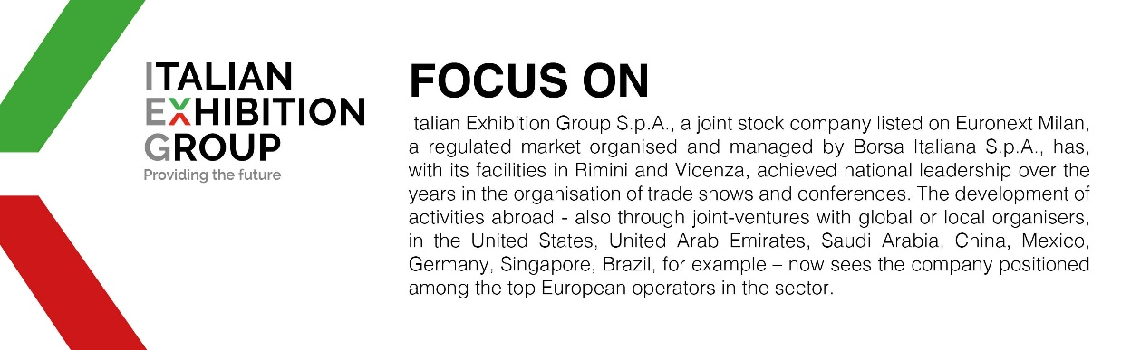

This press release contains forecast elements and estimates that reflect the management´s current opinions (´forward-looking statements´), particularly regarding future management performance, realization of investments, cash flow trends and the evolution of the financial structure. For their very nature, forward-looking statements have a component of risk and uncertainty, as they depend on the occurrence of future events. The effective results may differ (even significantly) from those announced, due to numerous factors, including, only by way of example: food service market and tourist flow trends in Italy, gold and jewellery market trends, green economy market trends; the evolution of raw material prices; general macroeconomic conditions; geopolitical factors and evolutions in the legislative framework. Moreover, the information contained in this release, does not claim to be complete, and has not been verified by independent third parties. Forecasts, estimates and objectives contained herein are based on the information available to the Company as at the date of this release.

