
press release no. 5

IEG, AT MIR 2026, TECHNOLOGY TAKES THE STAGE WITH LIVE YOU PLAY
- From 12-14 April at Rimini Expo Centre, four halls with active stages on which to test live audio, lighting and video systems in real operational conditions
- Immersive sessions for three-dimensional audio and an outdoor area to evaluate open-air sound power will be back at the Italian Exhibition Group event
- A unique format that transforms the show into a hands-on experience for technicians, designers and industry professionals

Rimini, 12.14 April 2026 – Back at Rimini Expo Centre, Live You Play, the exclusive format of MIR - Multimedia Integration Expo - an IEG - Italian Exhibition Group event where, instead of looking at the stage from a distance, visitors can cross it, listen and study right down to the smallest detail. Every element, from the supporting structures to the audio systems, lighting and videos, is real, switched on and installed, exactly like at a real concert. Not a simulation, not a prototype on display but a full-blown live production, designed to be analysed by those who devise and create that production every day. An ideal place for technicians, sound engineers, operators and designers who want to test above and below stage technologies, discover real workflows and converse directly with the specialists who conceived them.

FOUR STAGES, FOUR EXPERIENCES
The heart of the 2026 edition will beat in four halls entirely dedicated to live indoor performances, each with its own identity and technological vocation. Hall C1 will feature the art of integrated systems. Here the public will be able to see a setup in which the power of line array audio systems will merge with the visual impact of LED walls and the luminous design of the stage fixtures in a dialogue between technologies that shows how the true key to a quality production currently lies in integration between different sectors. Hall C2, on the other hand, will become a realm of dynamic entertainment between DJ sets and immersive live shows with an ecosystem in which lights, special effects and transparent LED surfaces will work in perfect synchrony with the audio systems, while spectacular light shows will put the potential of latest generation controllers to the test. Every aspect of electronic music and the most advanced live production will be housed in hall C3 through original formats such as The LightWalker and Live Busking sessions, which will explore the potential of timecode and synchronization workflows with robotic lighting systems, media servers and high-resolution LED surfaces that show how far technical creativity has come and what it can achieve.
Last but not least, Live You Play will bring the future of sound to the stage with the latest frontiers in immersive audio in hall C4, where the star attraction will be technology that uses machine learning to transform classic stereo setups into totally immersive spatial experiences, redefining the very concept of listening in a clubbing and live context.

IMMERSIVE ROOMS AND SOUND POWER: BEYOND THE STAGE
The experience will be completed with two complementary areas. Immersive Rooms will offer guided listening sessions to explore the potential of three-dimensional audio applied both to live events and permanent installations in theatres and prestigious architectural spaces, a sensorial laboratory where sound is no longer simple diffusion, but a physical body that envelops the listener. The external Sound Power area will feature testing systems for large open spaces in real conditions. Sound pressure, tone rendering and coverage uniformity are measured in the field, providing designers and sound engineers with a concrete and immediate reference.

ABOUT MIR 2026
Dates: 12/14 April 2026; event: international trade show; organisation: Italian Exhibition Group S.p.A.; frequency: annual; edition: 9th; entry: public and trade; info: www.mirtechexpo.com

PRESS CONTACT ITALIAN EXHIBITION GROUP
head of corporate communication & media relation: Elisabetta Vitali
press office manager: Marco Forcellini, Pier Francesco Bellini | press office coordinator: Luca Paganin | press office specialist: Mirko Malgieri; Nicoletta Evangelisti | press office assistant: Julia Andreatta media@iegexpo.it
MEDIA AGENCY MIR
Naper Multimedia| Zoe Perna | T. +39 02 97699600 | zoe.perna@napermultimedia.it | staff@napermultimedia.it

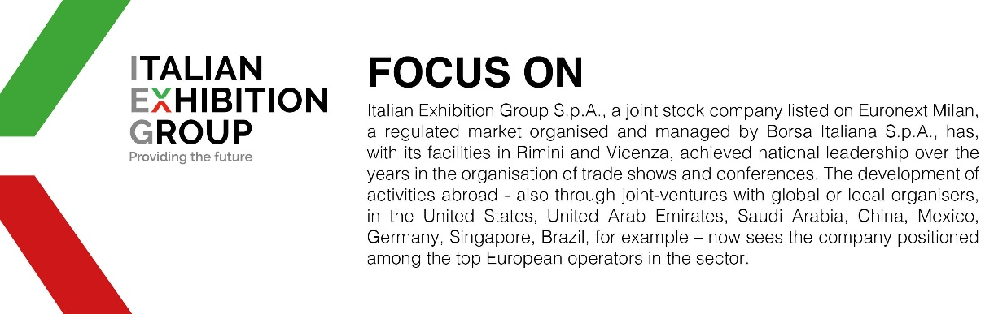

This press release contains forecast elements and estimates that reflect the management´s current opinions (´forward-looking statements´), particularly regarding future management performance, realization of investments, cash flow trends and the evolution of the financial structure. For their very nature, forward-looking statements have a component of risk and uncertainty, as they depend on the occurrence of future events. The effective results may differ (even significantly) from those announced, due to numerous factors, including, only by way of example: food service market and tourist flow trends in Italy, gold and jewellery market trends, green economy market trends; the evolution of raw material prices; general macroeconomic conditions; geopolitical factors and evolutions in the legislative framework. Moreover, the information contained in this release, does not claim to be complete, and has not been verified by independent third parties. Forecasts, estimates and objectives contained herein are based on the information available to the Company as at the date of this release.

